# **Which Is The Best Site, usukshop.com, to Purchase Negative Google Audits?**

Looking to give your online presence a boost? Want to stand out from the competition and attract more customers? Well, we've got just the solution for you. In this digital age, customer reviews play a crucial role in shaping public perception of businesses. Positive reviews can do wonders for your reputation, but what about negative ones? Surprisingly, they can actually work in your favor! In this blog post, we'll discuss why [**buying negative Google**](https://usukshop.com/product/buy-negative-google-reviews/) audits may be beneficial for your business and how it can help improve your internet-based presence. So buckle up and get ready to explore an unconventional strategy that just might take you to new heights!

## **For what reason Would it be a good idea for You to Buy Negative Reviews**

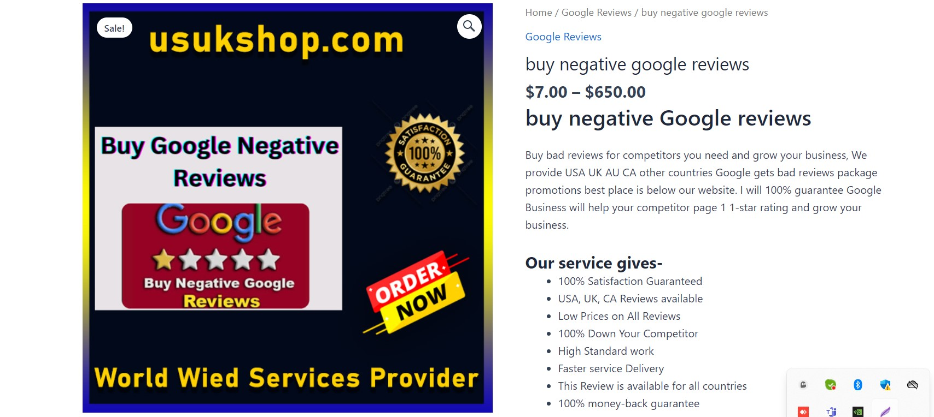

In the world of online business, reputation is everything. Positive reviews can certainly help build trust and attract new customers, but what about negative reviews? It may seem counterintuitive, but there are actually several reasons why buying negative reviews could be a smart move.  
  
It creates a sense of authenticity. In an era where consumer skepticism runs high, having only positive reviews can raise suspicions. By including a few negative ones in the mix, you demonstrate transparency and honesty.  
  
Negative reviews provide valuable feedback for improvement. They highlight areas where your business might be falling short or where customer expectations are not being met. This insight allows you to make necessary adjustments and ultimately enhance your product or service offering.  
  
Furthermore, buying negative reviews can also help level the playing field against competitors who may already have a substantial number of positive ratings. It gives you an opportunity to compete on a more equal footing by showcasing both positive and negative experiences.  
  
Remember, though, moderation is key when it comes to purchasing negative Google audits. You don't want to overwhelm your online presence with negativity; instead, aim for balance and credibility.  
  
So, if you're looking to add depth to your review spectrum while simultaneously improving your business model based on honest customer feedback – consider exploring the option of buying some carefully selected negative Google audits!

## **Improve Your Internet-based Presence by Buying a Variety Of Reviews**

Improve Your Internet-based Presence by Buying a Variety Of Reviews  
  
In today's digital age, your online presence is crucial for the success of your business. Positive reviews can significantly impact potential customers' perception of your brand and influence their purchasing decisions. However, it can be challenging to gather positive feedback organically.  
  
That's where buying a variety of reviews comes into play. By strategically purchasing negative Google audits, you can enhance your internet-based presence in several ways.  
  
Having a mix of [**positive and negative reviews**](https://usukshop.com/product/buy-negative-google-reviews/) adds credibility to your business. It shows that you are transparent and willing to address any concerns or issues raised by customers. This authenticity builds trust among consumers and increases the likelihood that they will choose your products or services over competitors.  
  
Additionally, buying negative reviews allows you to gain valuable insights into areas where there may be room for improvement. These critiques provide an opportunity for you to assess customer feedback objectively and make necessary adjustments to enhance the overall customer experience.  
  
Furthermore, having a diverse range of reviews makes your online presence appear more genuine and authentic. Customers are more likely to trust businesses with both positive and negative feedback as it demonstrates honesty and integrity.  
  
However, when considering purchasing negative Google audits, caution must be exercised. Ensure that the service provider is reputable and trustworthy so that the purchased reviews appear realistic rather than fabricated.  
  
To outperform competitors in terms of review quantity without raising suspicion from search engines like Google, it's advisable to gradually increase the number of negative audits over time instead of acquiring them all at once.  
  
Remember that while [**buying negative reviews**](https://usukshop.com/product/buy-remove-negative-reviews/) can be beneficial for improving your internet-based presence, it should never replace genuine efforts towards providing excellent products or services consistently.  
  
In conclusion (not concluding), investing in a variety of reviews through platforms like usukshop.com can positively impact your online reputation by boosting credibility, gaining valuable insights for improvement purposes, and showcasing authenticity within an increasingly competitive digital landscape!

## **What Would it be advisable for me to Be Careful about Assuming I Buy Negative Google Reviews?**

When considering purchasing negative Google reviews, there are a few important factors to be cautious about. While negative reviews can have a strategic advantage for your business, it's essential to approach this tactic with care and consideration.  
  
First and foremost, you should be careful about the source from which you purchase these negative reviews. There are many websites out there offering such services, but not all of them deliver genuine or reliable results. It's crucial to do your research and choose a reputable provider like usukshop.com that has a proven track record of delivering authentic reviews.  
  
Another aspect to consider is the timing and distribution of these negative reviews. It's essential to create a balanced online presence by maintaining an appropriate ratio between positive and negative feedback. This will help avoid raising red flags with customers or search engines that may suspect manipulation.  
  
Additionally, keep in mind that while negative reviews can influence potential customers' perception of your brand, they should not overshadow the quality of your products or services. Ensure that you continue providing exceptional customer experiences, as this is ultimately what will determine your long-term success.  
  
Always monitor the impact of these negative reviews on your online reputation carefully. Stay vigilant for any unexpected consequences or backlash from customers who may find them suspicious or misleading.  
  
[**Buying negative Google audits**](https://usukshop.com/product/buy-negative-google-reviews/) can be beneficial when executed properly; however, it requires caution and thoughtful decision-making throughout the process. By being mindful of these considerations and partnering with trusted providers like usukshop.com, you can leverage the power of targeted feedback strategically without compromising trust in your business!

## **What Number of Negative Google Audits Do I Have To Outclass Adversaries?**

When it comes to buying negative Google reviews, one question that often arises is how many do you actually need to outclass your competitors. While no fixed number guarantees success, the aim should be to have more negative reviews than your rivals. However, it is important to note that quality matters just as much as quantity.  
  
Having a significant number of negative Google audits can give the impression that your business has faced challenges and overcome them. It shows resilience and builds credibility among potential customers who value transparency. When people see a mix of positive and negative reviews, they are more likely to trust the authenticity of those reviews.  
  
The exact number of negative audits required varies depending on various factors, such as industry competition, target audience, and overall online presence. Analyzing your competitors' review profiles can provide valuable insights into their strategy and help you determine an appropriate benchmark for surpassing them.  
  
Remember, though, while [**buying negative Google**](https://usukshop.com/product/buy-remove-negative-reviews/) audits can be beneficial in some cases, it's essential to maintain balance by also focusing on improving customer experience and addressing genuine concerns raised in those reviews. Strive for a healthy blend of positive and negative feedback to show potential customers that you value their opinions and are dedicated to continuous improvement.  
  
To create an effective strategy for purchasing negative Google audits, consider working with reputable service providers like usukshop.com, who offer targeted solutions tailored specifically to your business needs. With their expertise in managing online reputation effectively through strategic review management techniques, you can gain an edge over your competitors without compromising integrity or credibility!  
  
So, rather than fixating on a specific number of negative audits needed to outshine your adversaries, focus on building a comprehensive online presence backed by genuine customer experiences – both positive and constructive. By maintaining transparency and actively engaging with feedback from all sources (including purchased negatives), you will demonstrate authenticity while continuously striving toward growth!

## **Our Service Always Trusted Customers with sufficient Guarantee**

If you are looking to improve your online presence and outshine your competitors, purchasing negative Google reviews can be a strategic move. However, it is crucial to approach this strategy with caution and ensure that you choose a reliable service provider.  
  
USUKShop.com is the best site to purchase negative Google audits as they offer trusted services and provide customers with sufficient guarantees. With their expertise in delivering authentic-looking negative reviews, you can enhance your credibility by showcasing a diverse range of feedback.  
  
Remember, while buying negative reviews may seem counterintuitive at first glance, it can actually work in your favor when done right. By providing potential customers with a balanced view of your business and addressing any concerns or issues raised in these reviews, you demonstrate transparency and authenticity.  
  
So why wait? Take advantage of USUKShop.com's reliable service today and watch as your online presence grows stronger than ever before. Remember, quality matters more than quantity – focus on receiving just enough negative Google audits to create an impact without overwhelming potential customers.  
  
Boosting your brand image has never been easier – trust USUKShop.com for all your review needs!